AVR STUDIO

AVR Studio 4 is a professional Integrated Development Environment (IDE) for writing and debugging AVR applications in Windows 9x/NT/2000/XP environments. This tutorial assumes that you have installed AVR Studio 4 on your computer. If you do not have AVR Studio yet, you may obtain a copy of AVR Studio 4 from one of 3 places:

1. Atmel Corporation: http://www.atmel.com
2. AVR Freaks: http://www.avrfreaks.net
3. Borrow a CD from your instructor
This will guide you through the steps required for:
1. Executing the AVR Studio 4 Integrated Development Environment (IDE),
2. Typing in a program,
3. Assembling the program, and
4. Simulating a program
Step 1: Open AVR Studio 4 IDE. You should see the program banner shown below:



Figure : AVR Studio 4 Banner
Step 2: When IDE opens, you will see the programming and simulator environment as well as a
dialog box (Figure 3) requesting infor-mation: are you starting a new project or opening a saved

project?

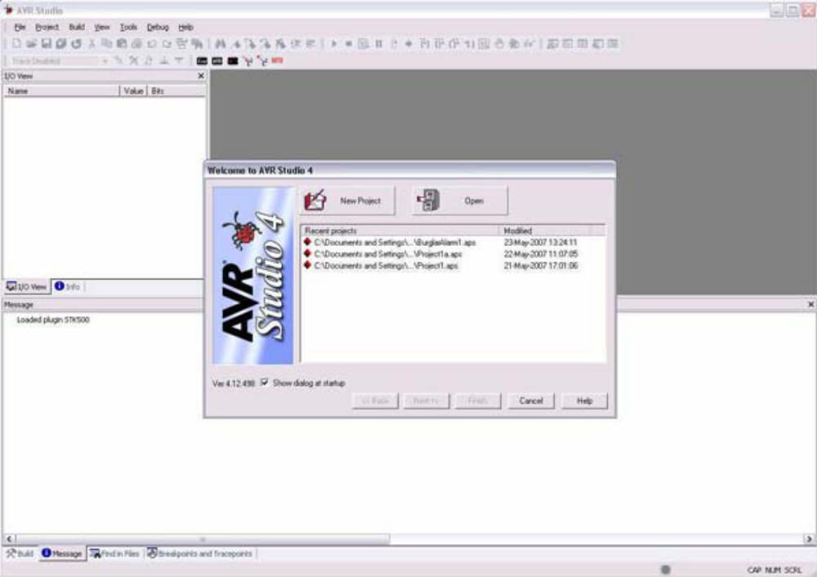

Step 3: Click on the “New Project” button:
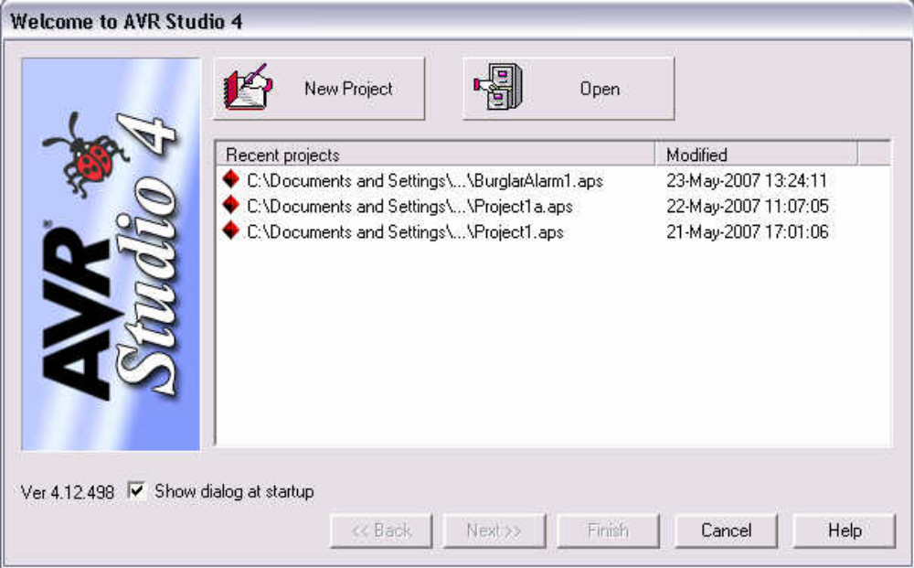
Step 4: In the next dialog box, choose the Atmel AVR Assembler as the project type:

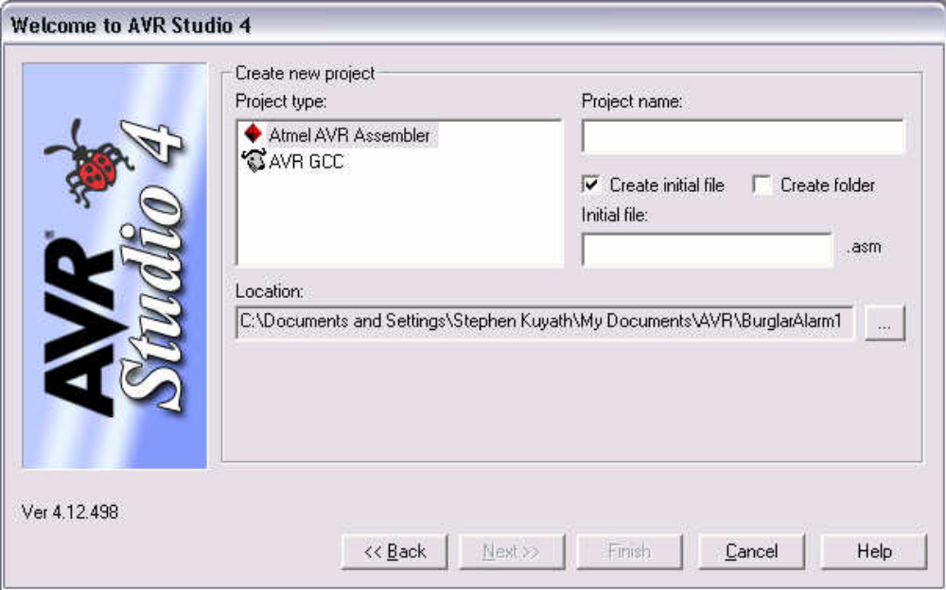

Figure : Choose Atmel AVR Assembler

Step 5: Type in a project name and the initial file name:

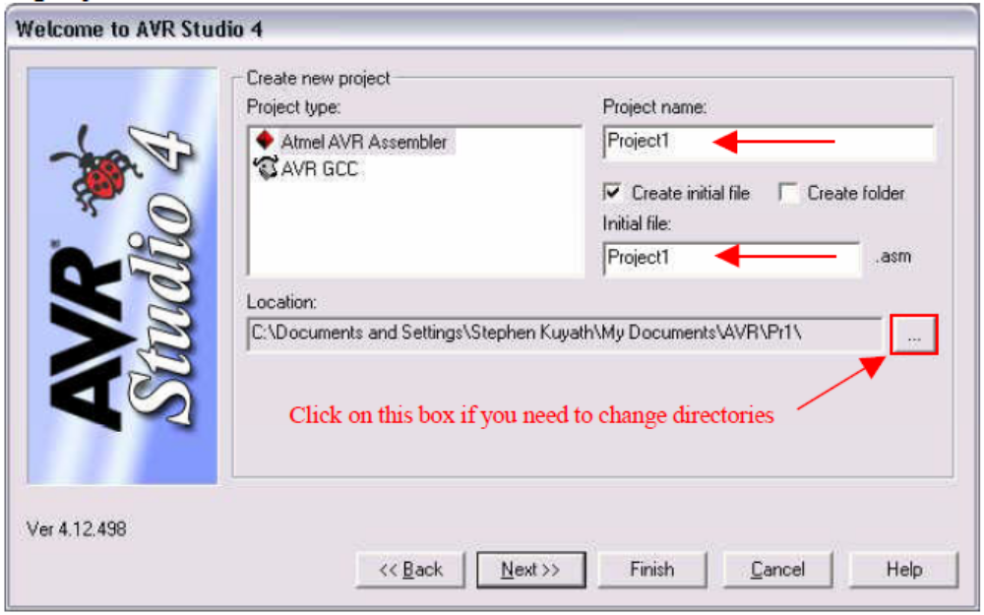
Figure: Type Project and Initial File Names
Step 6: Click on the “Next” button
Step 7: Choose “AVR Simulator” for the Debug Platform and then scroll down the right window
to choose the ATmega32 AVR processor. Select in the drop down list.Choose Simulator and ATmega32

Step 8: Click on the “Finish” button. You should then see the IDE (you may have to maximize
the editing window to see the same thing as shown in Figure 8):

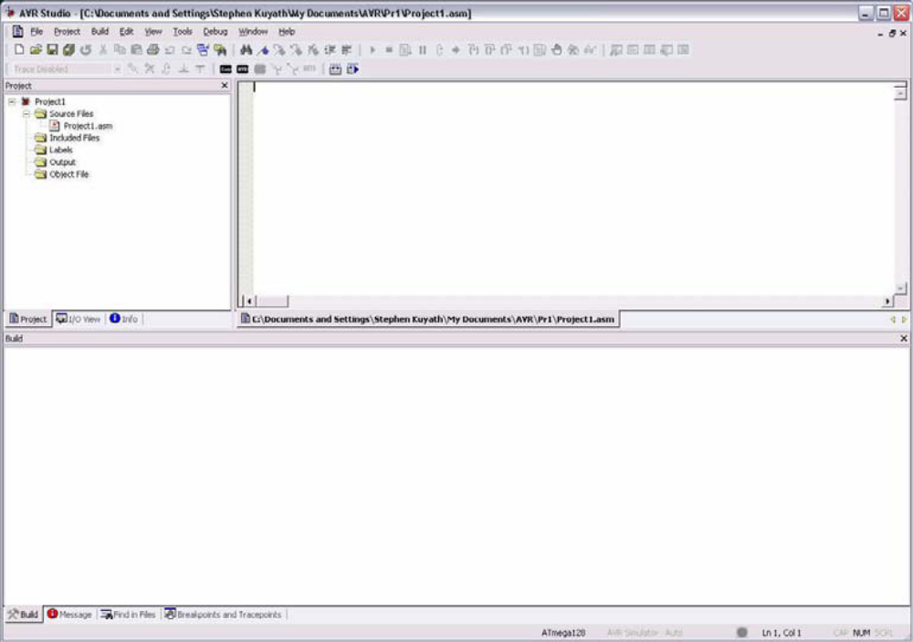
Figure : AVR Studio 4 IDE

Step 9: Type in the program as shown in Figure 1. Note the color-coded text. This is done
automatically by the IDE and helps you to make corrections as you go.
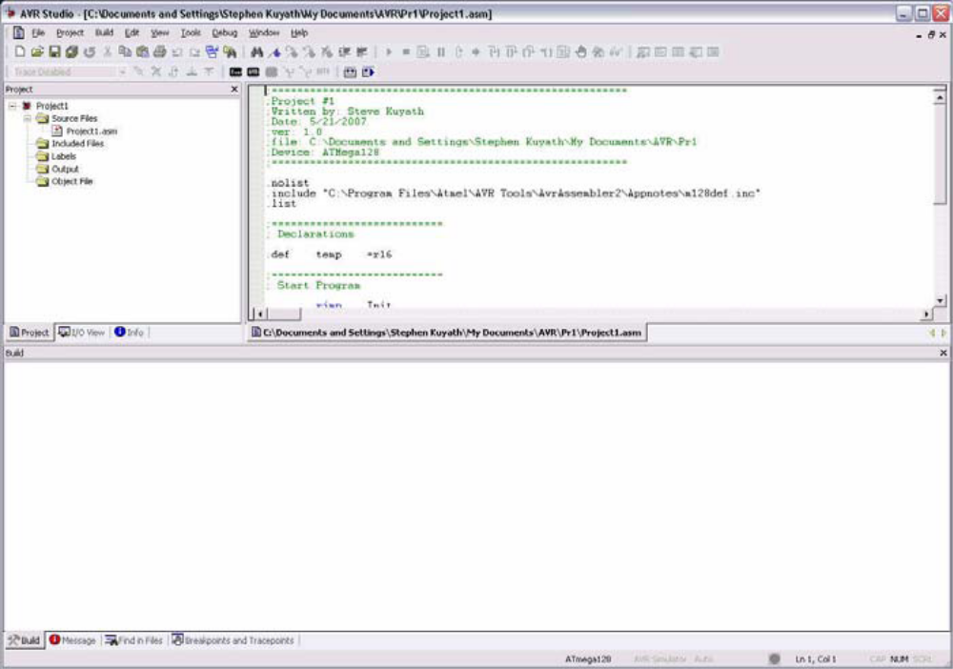
Step 10: When you have completed the program save it. It is also good practice to periodically
save your program as you type.
Step 11: Assemble your program. You may do this by selecting “Build” from the “Build Menu”
or by striking the [F7] key:
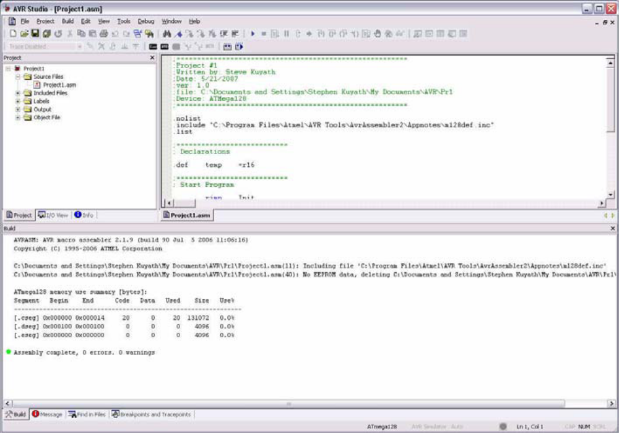
Figure Program Assembled
Step 12: Continue assembling and correcting errors until the program assembles without error
(Note the green dot in the lower window and the comment that states: “Assembly complete, 0
Errors, 0 warnings”) you are ready to simulate.
Step 13: Simulate the program. To start the simulator you may choose “Start Debugging” from
The “Debug Menu” or you may click on the arrow button as shown below:

